**Train Time Complexity: O(n logn d \* k)**

Here n logn d is DT run time complexity and K is the number of base learners we are using.

But todays world of clusters like hadoop and multi core boxes, all base learners can be trained parallel, because all base learners have separated data independent of each other.

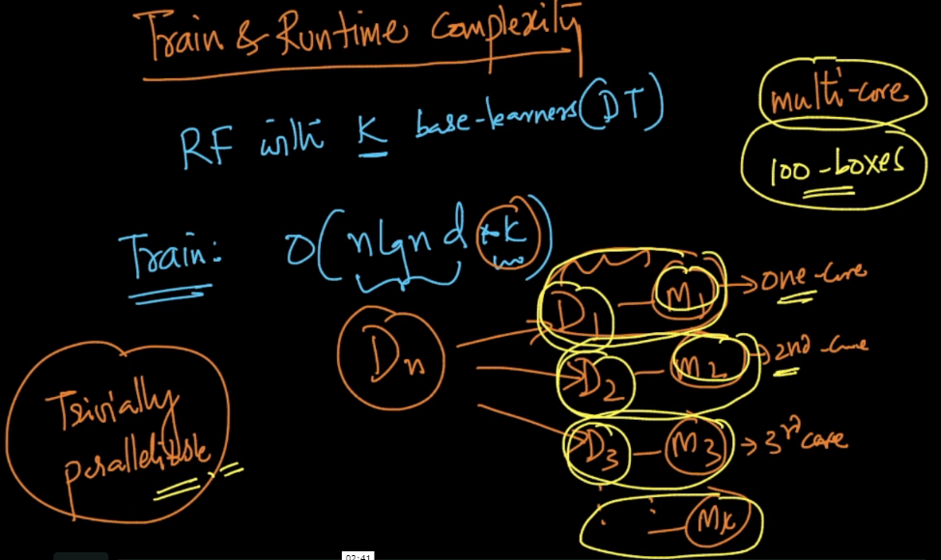

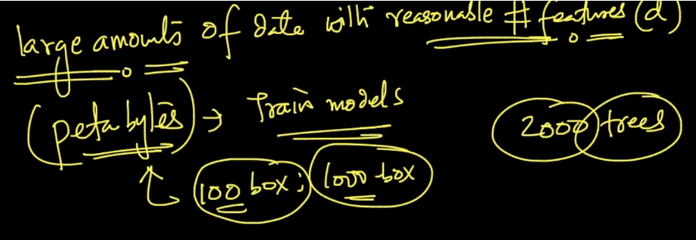

**Run time Complexity: O(depth \* k)**

Here depth can be large(10 to 20) and k can be find using cv.

Since run time complexity for one DT is O(depth) and we have k such DT.

**Space Complexity: O(DT \* K)**

Here each DT can be stored using if else script, and in todays world all programming language provide efficient if else computation

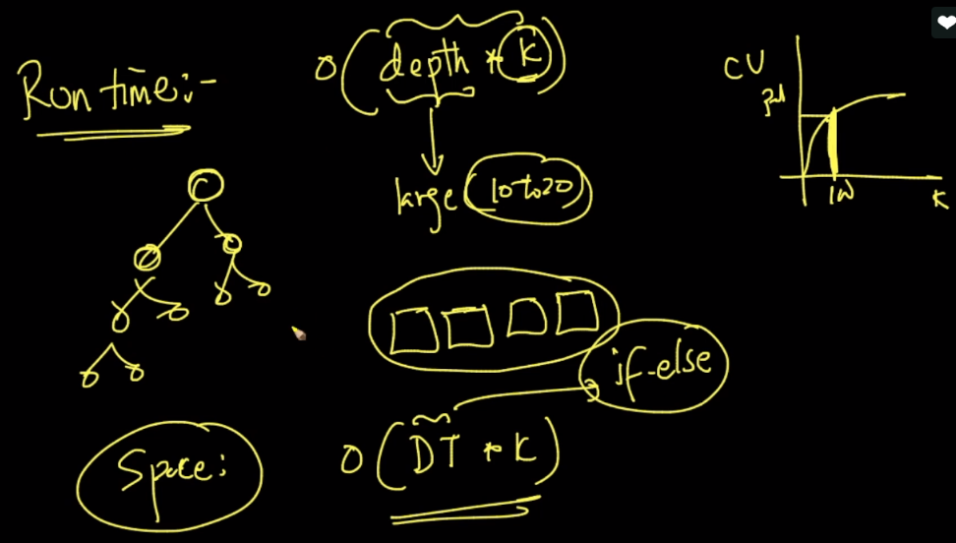

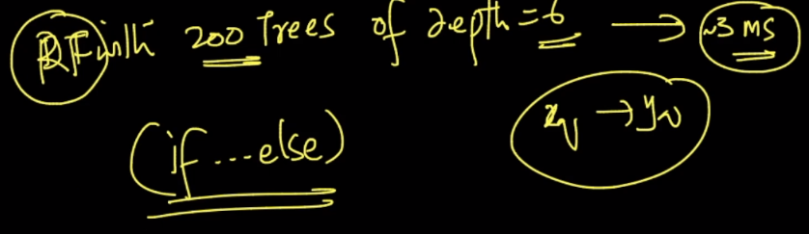

<https://towardsdatascience.com/why-random-forests-outperform-decision-trees-1b0f175a0b5>

